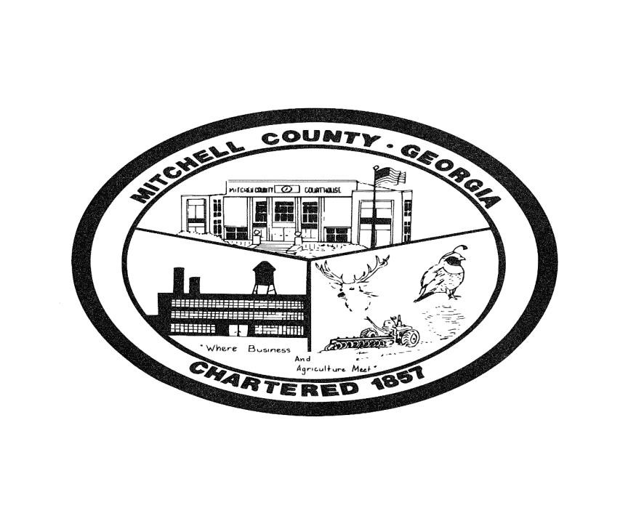

REQUEST FOR QUALIFICATIONS
FOR
ARCHITECTURAL SERVICES

CONCEPT STUDY
MITCHELL COUNTY COURTHOUSE

Mitchell County BOC 26 N. Court Ave.
Camilla, Georgia 31730

Issue Date: October 1, 2020

REQUEST FOR QUALIFICATIONS
FOR
ARCHITECTURAL SERVICES

Mitchell County BOC
Mitchell County, Georgia

Publish Date: October 1, 2020 Submission Deadline: November 16, 2020

A. INTRODUCTION
The Mitchell County BOC is seeking proposals from qualified architectural/engineering firms (the “Architect”) to develop a Feasibility Study for the Mitchell County Courthouse, a Level One SPLOST of the 2018 Mitchell County SPLOST. Mitchell County seeks consulting services from architecture firms relating to concept development and budgeting for renovations of the Courthouse. The county desires to have a general concept of the project. This RFQ does include a contract for actual full architectural design of and construction oversight for the facility.
The purpose of this RFQ is to solicit meaningful information so that the Commission may select a qualified architectural/engineering firm. The Commission urges all interested firms to carefully review the requirements of this RFQ. Written qualification submittals containing the requested information will serve as the primary basis for final selection. All proposals will be reviewed by an RFQ committee and recommendations from this committee will be made to the Mitchell County BOC for final award. The Mitchell County BOC reserves the right to select a firm based on the responses to this RFQ and responses to interviews at their discretion.
This RFQ establishes the general specifications for the professional services needed and provides prospective firms with sufficient information to enable them to provide an acceptable response to this RFQ. Questions and inquiries regarding this RFQ must be in writing and submitted no later than October 16, 2020, at 2:00 P.M., EST to the following email: jpermenter@Mitchellcountyga.com and grice@mitchellcountyga.net . Answers will be provided as written addendum to this RFQ, issued by email and posted to the Mitchell County website. Answers will be issued as soon as possible, but no later than 5:00 P.M., October 20, 2020.
The Commission shall not be responsible for the costs incurred by any proposer or potential proposer in their preparation of the proposal or for any visits to the Property. All such costs are the responsibility of the proposer.

B. BACKGROUND
The Mitchell County Courthouse, built in 1936, is located in an area designated as a historical district. The Courthouse needs attention in the areas of HVAC, fire protection, roofing, exterior walls and potentially plumbing, electrical, and some interior finishes. The Courthouse is located at 11 West Broad Street, Camilla, Ga. 31730
The County faces a number of issues with this building, including:

oOld HVAC units and control system need to be replaced oOld, leaky roof causes moisture problems in building oExterior walls leaking and needs repointing and sealing oFire protection needs to be addressed oPossibly needs some accessibility upgrades oNeeds interior finish/lighting upgrades

C. GOAL
The overall goal of the Study is to provide the Mitchell County BOC with the most viable option to alleviate the problems existing in the Courthouse. A prioritized schedule of work would need to be provided to ensure the most critical issues are addressed first to secure the exterior of the building to make it leak resistant. After securing the exterior, the interior renovations will be prioritized.

D. SCOPE OF SERVICES
- Analyze and prioritize the Courthouse building to determine highest and best use to include evaluating needed repairs. This will be a phased repair schedule as this could span many years.
- Develop options for renovation and repairs of the Mitchell County Courthouse to present at a Work Session with the Commissioners.
- Provide a final report with plans and cost data for the most viable option(s). While these plans do not have to be fully ready for construction, they must be advanced enough to provide an accurate cost estimate for budgeting purposes. We cannot stress enough the importance of the cost data.

E. INSTRUCTIONS FOR PROPOSERS
- General. The instructions below provide guidance for the preparation and submission of proposals. Their purpose is to establish the requirements, format, and content of proposals so that proposals are complete, contain all essential information, and can be evaluated fairly.
- Submission and Content of Proposals. All proposals must be received in the office of the Commission no later than 2:00 P.M., EST on November 1,2020 (the “Submission Date”) at the following address and marked on the outside as follows:
Mitchell County BOC
Attn: Jerry Permenter, Finance Department26 N. Court Ave.
Camilla, GA 31730

Proposals shall be submitted in original and seven (7) complete copies, prepared in the format and detail as outlined below. Please include an electronic copy saved on a flash drive. All material must be submitted in an 8” x 11” format. E-mailed proposals will not be accepted. All proposals will be valid for ninety (90) days. A proposer may select any mode of delivery; however, the risk of non-delivery shall remain with the proposer.
The qualifications statement shall be divided into tabbed sections and, at a minimum, contain the following:
- Introduction Letter:Include a letter of introduction including the firm’s name, address, telephone number, and email address. Provide the name, title, address, and telephone number of the official firm contact. This individual should be available by telephone or email to provide clarifications to questions. Provide a brief firm history, and provide the location of the firm office that will be responsible for this project. Provide the legal status and Federal Tax ID number of firm.
- Outline Methodology to accomplish the Study: Provide a methodology to describe the firm’s approach to the project and a proposed plan of action to complete the Study within a reasonable time frame.
- Statement of Experience and Qualifications: Provide a brief profile of the proposer’s principal staff to be employed for the Study. Describe the experience of the individuals, through summary resumes, responsible for this effort with a list of similar project experience that they have completed. Provide the years of experience for the professionals and staff member to be providing services. Describe previous projects for which the proposer has developed a comprehensive study for similar facilities. List any consultants and describe their role. Provide an outline of the proposer’s current workload and how that workload will affect the timely completion of this project.
- Supporting Materials: Provide materials that the proposer deems useful in further helping the Commission determine the firm’s experience and qualifications, specific to this type of project.
- References: Provide a reference list of five (5) clients for whom the proposer has developed a comparable study. Of the five references at
least two government project references are required. Include name, address, telephone number, email address, contact person, and project name. Additionally, for each reference listed, submit a brief summary of the scope of services provided.
- Disputes and complications: Provide a history of disputes and complications your firm has been involved with relating to any projects it has worked on. Disclose and clearly state whether the firm was terminated from or for any reason has ever failed to complete a project. If so, list the date of commencement of the project and the entity for which the project was to be performed, and explain why the project was not completed. Disclose information and provide explanation regarding any contracts involving your firm within the last three years which exceeded initial program or project budget, exceeded initial schedule, and disclose any penalties or damages assessed. Disclose any past (within last 10 years) or current litigation, arbitration, mediation, etc. which the firm are or were involved.
- Pricing: Submit the hourly rates you would propose for the principal and all other levels of billable employees. Submit any other general conditions or billing practices.
- E-Verify: Proposed bidders must comply with all the provisions of the “Georgia Security and Immigration Compliance Act” of 2007 and Georgia Code 13-10-91 and 50-36-1. A completed E-verify form must be submitted before any response can be considered.
- Insurance Requirements:Provide a statement regarding the firm’s understanding and ability to comply with required insurance requirements as outlined in this document (Section I). Include copies of your current insurance certificates.
- Acknowledgement of Receipt of Addenda: The county will endeavor to provide copies of addenda to all potential proposers to whom this RFQ has been delivered. However, it is the responsibility of each proposer to inquire as to the existence and content of addenda as the same shall become part of the RFQ and all proposers will be bound thereby. The proposer shall include a statement of acknowledgement of all addenda to the RFQ. Proposer’s failure to acknowledge an addendum may result in rejection of the proposal.

- Retention of Proposal. All proposals are the property of the Commission and shall be retained by the Commission. Proposals shall not be returned to the proposer.
- Discretion of the Commission; Cancellation and Waiver. The Commission reserves the right to cancel or terminate this RFQ in whole or in part, or to reject, in whole or in part, any and all proposals received in response to this RFQ, upon their determination that such cancellation or rejection is in the best interest of Mitchell County. The Commission further reserves the right to waive any informalities in any proposals received. The determination of the criteria and process whereby proposals are evaluated, and the decision as to who shall receive a contract award, or whether or not an award shall be made as a result of this RFQ shall be at the sole and absolute discretion of the Mitchell County Commission.

F. SELECTION PROCESS
It is anticipated that a short list of firms will be selected for interviews which may be by telephone. The winning firm will be chosen by the Mitchell County Board of Commissioners based on the proposal contents, possible interviews, qualifications of personnel, prior experience of the firm for the type of work proposed, proposed methodology, references, and pricing.

G. SELECTION & PROJECT TIMELINE
Publish RFQ…………………………………………………………………………………October 1, 2020

Submit questions in writing……………………………………….................. October 16, 2020 by 2:00 PM

Issue answers to questions…………………………………………….………….. October 20, 2020 by 5:00 PM

Deadline for RFQ proposal submission………………………………………. November 2, 2020 by 2:00 PM

Interviews if required....…………………………………………………………….. Week of November 9, 2020

Selection Notification……….………………………………………………………. November 16, 2020

Contract Award………………………………………………………………………….December 8, 2020

Anticipated deadline for concept plan and budget……………………..March 15, 2021

H. CONTRACT AWARD
The Commission expects to enter into contract negotiations with the top ranked proposer during which time the Commission and the proposer will resolve any necessary issues that need to be addressed prior to entering into the Architect Agreement. Upon successful completion of such negotiations and discussions, the Commission and the selected Architect shall enter into the Architect Agreement. If, in the sole judgment of the Commission, these negotiations are not successful, the Commission reserves the right to enter into negotiations with other proposers, proceeding in the order of their initial ranking.

I. INSURANCE REQUIREMENTS
The successful firm agrees to maintain in full force at all times during the contract term the following insurances. Provide documentation of the following:
- Workers Compensation Insurance - $1,000,000
- General Liability Insurance in the amount of at least 1,000,000 per occurrence
- Automobile Liability insurance in the amount of at least $1,000,000 for each occurrence
- Professional Liability insurance in an amount that correlates to the amount of this agreement and nature of work required
- Errors and Omissions Insurance in an amount that correlates to the amount of this agreement and nature of work required
All such insurance policies shall provide that they not be canceled without (30) days prior written notice to the Mitchell County BOC, Attention: Gary Rice, 26 N. Court Ave, Camilla, Ga. 31730. Mitchell County shall be named as additional insured under the insurance policies upon contract award.

